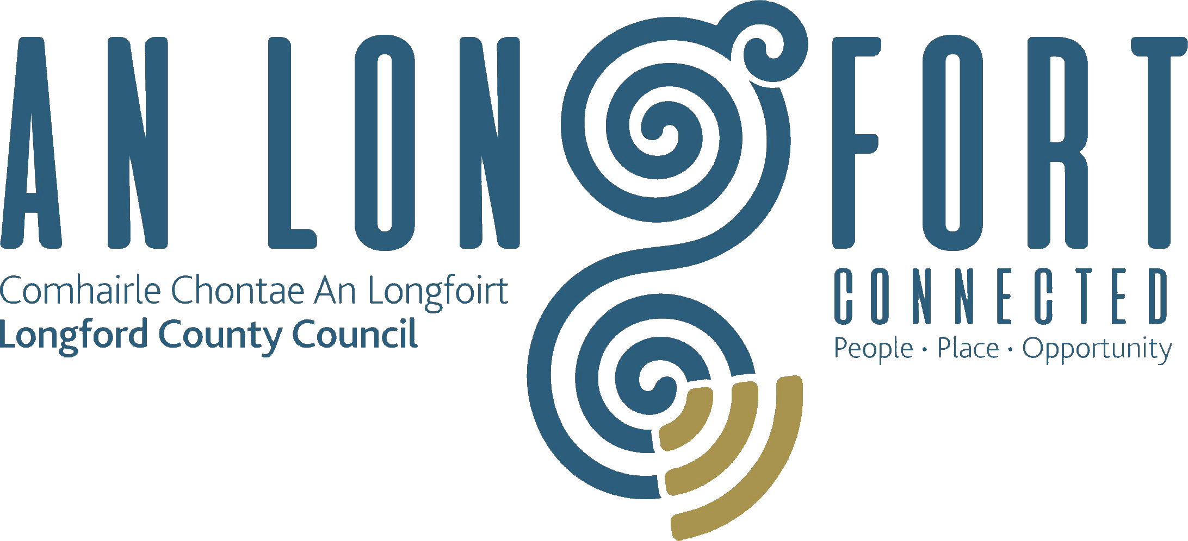

BALLYMAHON MUNICIPAL DISTRICT

Minutes of Annual Meeting of Ballymahon Municipal District held in the
Sports Hall, Leisure Centre, Albert Reynolds Peace Park, Longford
on Thursday, 18th June 2020 at 4.00 p.m.

__________________________________________________________________________

CATHAOIRLEACH: Councillor Pat O’Toole.

MEMBERS PRESENT: Councillors – Mick Cahill, Mark Casey, Gerard Farrell,
Colm Murray and Paul Ross.

IN ATTENDANCE: Ms. Barbara Heslin, Director of Services.
Ms. Linda Higgins, Administrative Officer.
Mr. Paul Newell, Senior Executive Engineer.
Mr. John McKeon, Director of Services.

MEETINGS
ADMINISTRATOR: Ms. Anne. Lee.

Standing Order No. (27) (a) - Matters not covered by Standing Orders.
Standing Order No. (4) (a) - Place of Meeting.

Councillor Pat O’Toole, Cathaoirleach, referred to the following Sections of the Ballymahon Municipal District Standing Orders -

- No. (27) (a) - Matters not Covered by Standing Orders -
The Cathaoirleach will have power to deal with any matter not covered by Standing Orders

- No. (4) (a) - Place of Meeting
The Meetings shall be held in the Community Library, Ballymahon.

On the proposal of the Cathaoirleach seconded by Councillor C. Murray, it was unanimously agreed that due to the COVID-19 Pandemic, today’s meeting of Ballymahon MD be held here in the Sports Hall, Leisure Centre, Albert Reynolds Peace Park, Longford.

It was noted that it is strongly recommended by the Department that formal decisions, which are required under statute to be made by a Council at a meeting properly constituted under the Local Government Act 2001, be taken at meetings held in a physical place.

Tragic Death of Detective Colm Horkan.

A minute’s silence was held in memory of Detective Colm Horkan.

ELECTION OF CATHAOIRLEACH.

The outgoing Cathaoirleach, Councillor Pat O’Toole, thanked the members and staff for their support over the past twelve months and outlined a number of highlights during his term as Cathaoirleach.

It was proposed by Councillor P. Ross and seconded by Councillor M. Cahill that
Councillor Colm Murray be elected Cathaoirleach of Ballymahon Municipal District
As there was no other nomination, Councillor Murray was, thereby, elected Cathaoirleach of Ballymahon Municipal District until the Annual Meeting in 2021.

ELECTION OF LEAS CATHAOIRLEACH:

It was proposed by Councillor P. O’Toole and seconded by Councillor G. Farrell that Councillor Mick Cahill be elected Leas Cathaoirleach.

As there was no other nomination, Councillor Cahill was, thereby, elected
Leas Cathaoirleach of Ballymahon Municipal District until the Annual Meeting in 2021.

Councillor Murray thanked his proposer and seconder and the Members for electing him as Cathaoirleach of the Municipal District for the coming twelve months and congratulated Councillor Cahill on being elected Leas Cathaoirleach.

He stated that he will work ardently for the Municipal District during his term as Cathaoirleach and outlined his priorities for the year ahead.

All the Members joined in wishing Councillor Murray every success during his term of office as Cathaoirleach and also congratulated Councillor Cahill.

Councillor Cahill thanked his proposer and seconder and congratulated Councillor Murray on being elected Cathaoirleach.

Barbara Heslin on her own behalf and on behalf of the employees of the Council joined with the Elected Members in congratulating Councillors Murray and Cahill assured them of the full support of the Municipal District team during their term of office.

ARRANGEMENTS FOR BALLYMAHON MUNICIPAL DISTRICT MEETINGS.

It was agreed that Ballymahon Municipal District Meetings be held on the fourth Thursday of every second month commencing at 4.00 p.m. in Ballymahon Community Library.

Municipal Districts – Change of Directors.
B. Heslin gave details regarding the change in Directors in charge of Municipal Districts -
Ballymahon MD - John McKeon supported by Mark McNerney
Granard MD - Barbara Heslin supported by Linda Higgins
Longford MD - John Brannigan supported by Ann Marie McKeon
Barbara stated that it had been a pleasure working with the Ballymahon MD members and referred to a number of projects which came to fruition and delivered during her term and a number of ongoing projects and planned projects which would deliver sustainable community and economic development.
The Cathaoirleach and members thanked Barbara and Linda for their outstanding service to the Ballymahon MD.

This concluded the business of the meeting.

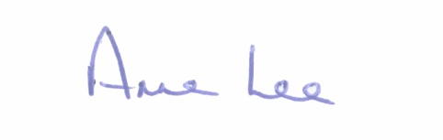

Signed: __________
Anne Lee,
Meetings Administrator.

Confirmed and adopted at Ballymahon Municipal District Meeting held on the
23rd July 2020.

Signed: _______________
Cathaoirleach.

